**Project Design Phase-II**

**Data Flow Diagram**

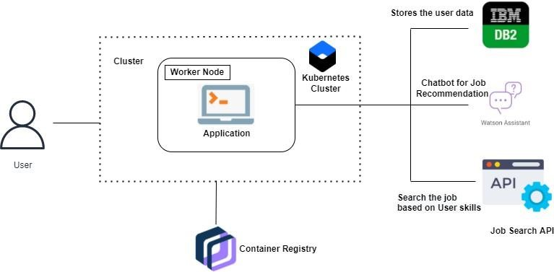

**Data Flow Diagrams:**

A data flow diagram (DFD) maps out the flow of information for any process or system. It uses defined symbols like rectangles, circles and arrows, plus short text labels, to show data inputs, outputs, storage points and the routes between each destination. Data flowcharts can range from simple, even hand-drawn process overviews, to in-depth, multi-level DFDs that dig progressively deeper into how the data is handled.